Zoom’s Operation Manual

Online ZOOM test on April 22, 2022 in GMT+7 (Viet Nam Local Time):
- Test Room 1
Conference ID: 847 0402 7844
Invitation Link: https://us02web.zoom.us/j/84704027844

Note: Afterwards, the conference secretary will send you the detailed zoom test arrangements together with the conference abstract.

Online meeting on April 23-24, 2022 in GMT+7 (Viet Nam Local Time):
- Online Meeting Room
Conference ID: 847 0402 7844
Invitation Link: https://us02web.zoom.us/j/84704027844

- Sometimes due to some unknown bug of ZOOM, when you join in the online conference room, it may show: The conference has ended or it doesn’t exist. If in this case, please come to the following website to download the newly version again.
www.zoom.com.cn/download
- In order to have a better experience for your conference participation, please download Zoom and be familiar with the following guidelines before ZOOM Test. The ZOOM test will be arranged on April 22, 2022 in GMT+7 (Viet Nam Local Time).
- Join in the meeting room in the requested name format (If you are conference committees or keynote speaker: Keynote—Vicky Liu; If you are participant: DM001—Vicky Liu). Only above participants will be permitted to join in.
- If you have any question, you are welcome to contact with the conference staffs.
- Before entering the online meeting room, please pay attention to these tips as follows:
- Stay in quiet circumstance
- Keep stable network
- Computer audio and video work normally
- Pay attention to the time difference (All conference time schedule is in GMT+8)
Step 1: Download and Install ZOOM
Step 2: Join in a New Meeting without Sign-in
Step 3: Name
Step 4: Basic Operations(Start Video, Share Screen, Chat, etc.)
Step 5: Other Questions

Step 1: ZOOM Download and Install
Download the ZOOM on your PC and complete the ZOOM install before the conference.

Link: www.zoom.com.cn/download

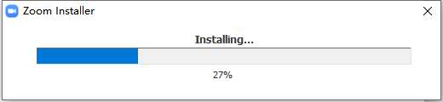

ZOOM has been installed successfully.

Step 2: Join in a New Meeting without Sign-in
Click “Join a Meeting”Input the conference ID and your name in the requested format.
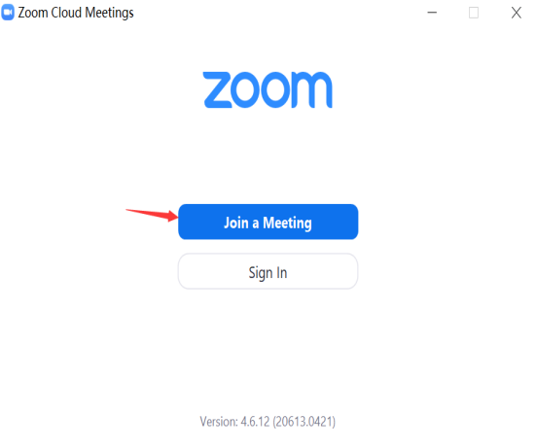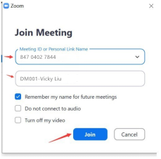

Sometimes, ZOOM will request you to input your telephone number and enter 6-digit code. Just input your telephone number in the 1st blank click “Send Code” then your phone will receive a text message with the code. Please input it.
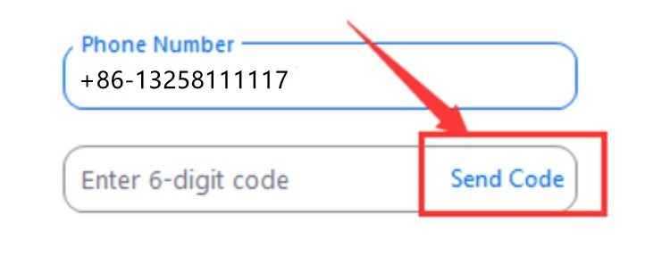

Please click “Join with Computer Audio” Otherwise, you cannot listen any sound of the conference.
Afterwards, you will enter a waiting room. Please wait a moment.

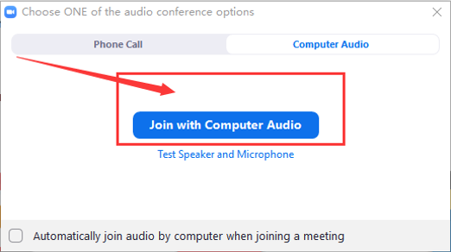
At last, this is the interface sample of the meeting room.
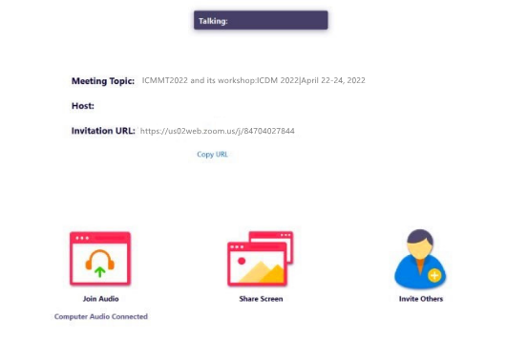
Step 3: Name
Note: Please name according to the following format.
- If you are a conference committee member or keynote speaker, please set up your name by this format: your position-FULL Name, such as, Keynote-Vicky Liu.
- Or, if you are participant, please set up your name by this format: Paper ID-FULL Name, such as DM001—Vicky Liu.

After entering the meeting conference:
Please click the option “participants” and find your name. And please chose the option “More”“Rename” “Enter a New Screen Name” (Paper ID- Name) “OK”.
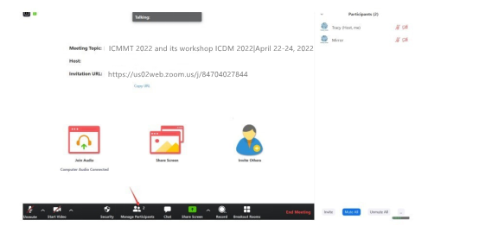
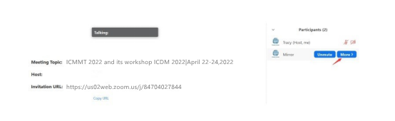
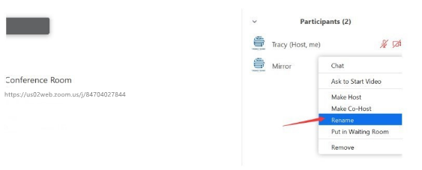
Step 4: Basic Operations
- Start Video:
It is in the bottom of the window. Please click it and turn on the video. (the button “Start Video”).
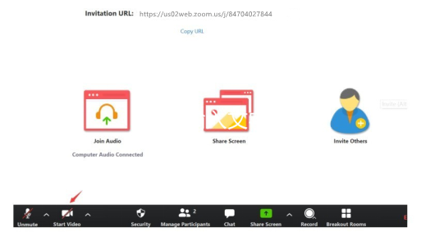

- Share Screen

Note:
- Please open the PPT file on the computer desktop in advance.
- Please click “share screen”choose the PPT you need to displayclick the option “Share Computer Sound” click the button “Share”. There may be several seconds’ delay for other participants to see your share.

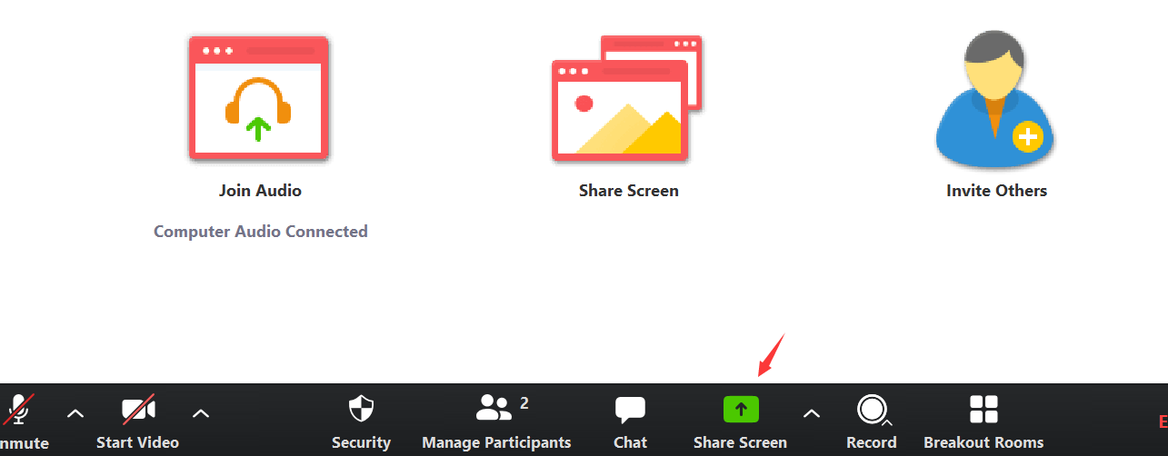
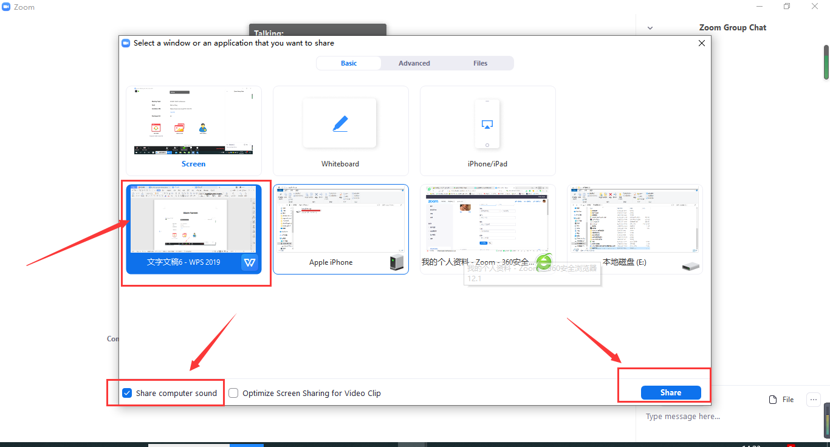
- During your presentation, you are suggested to use the “spotlight” in the ZOOM. Please move the mouse to the top of the window, then click the option: “Annotate”“Spotlight”.
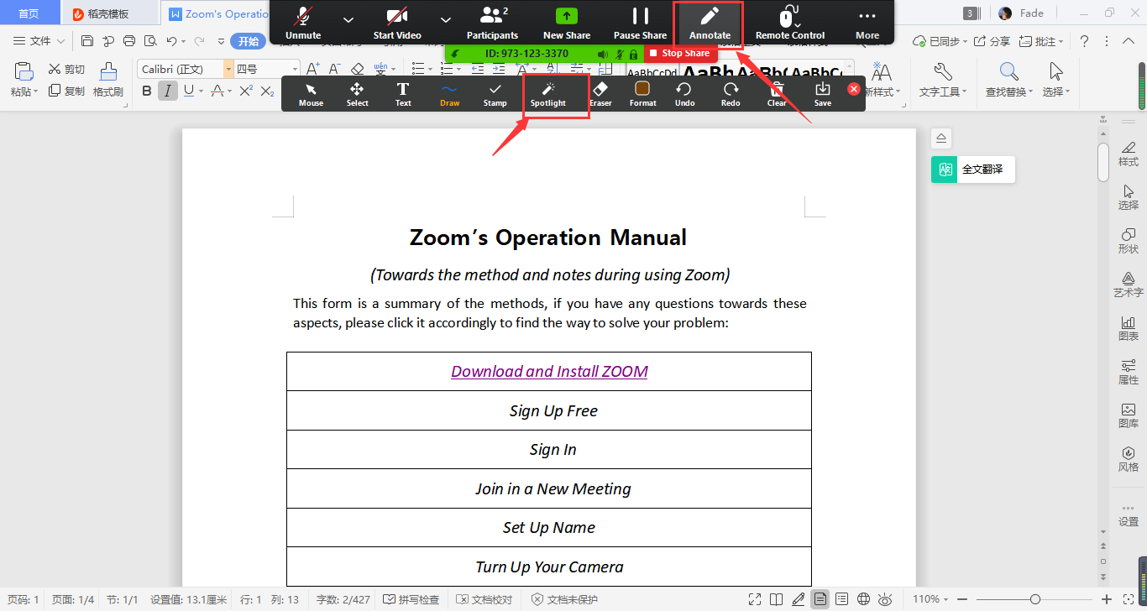
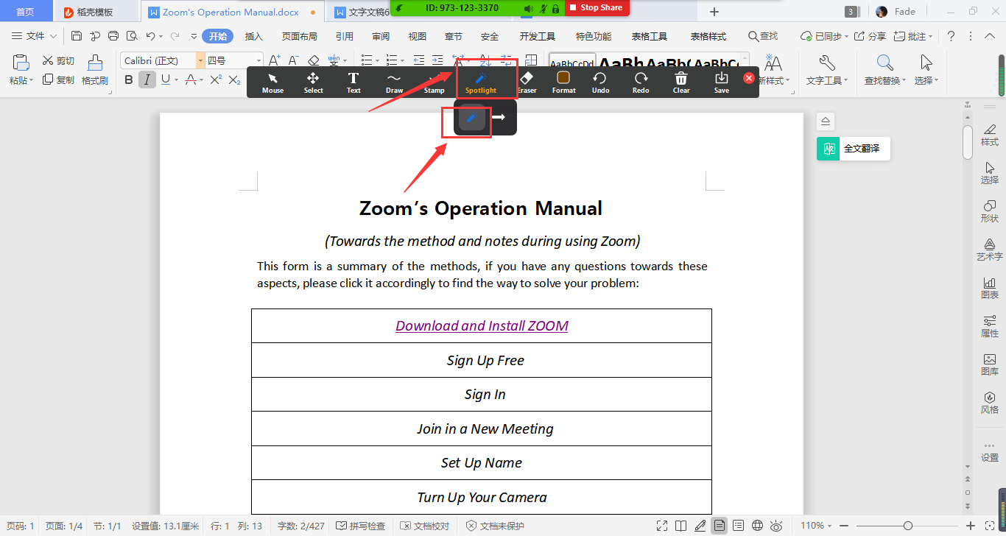

- If you’d like to share another files, such as, video, please click the button “New Share”. After your speech finished, please click the phrase “Stop Share” to stop it.
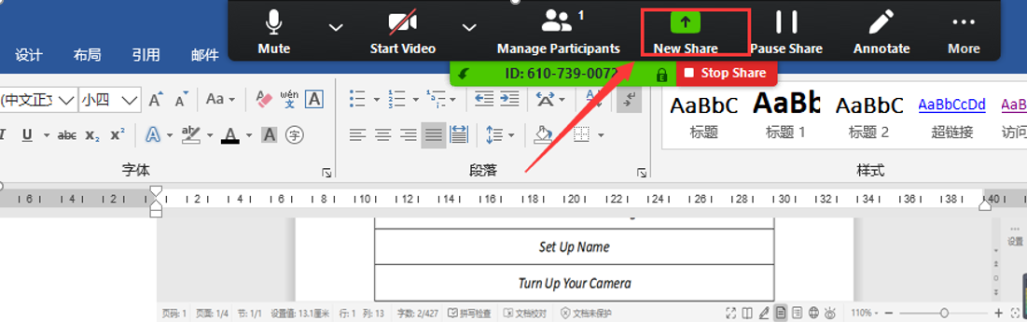
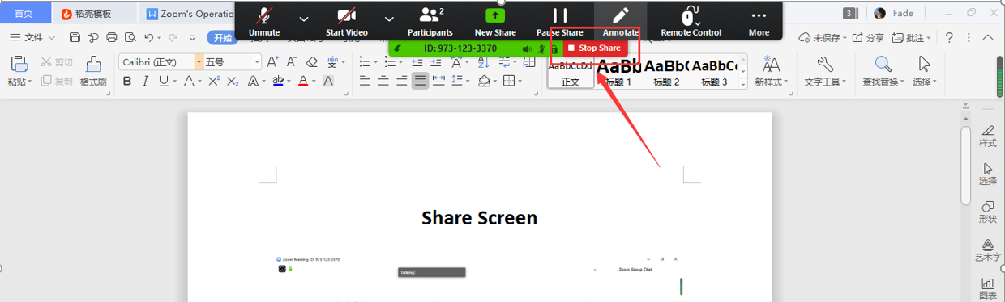

- Chat Room
- Click “chat” and input the message to everyone or only one people privately.
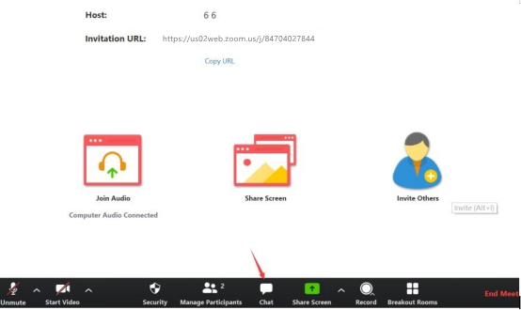

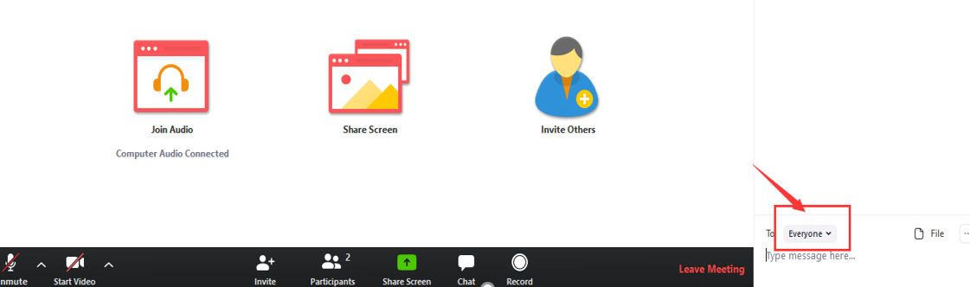

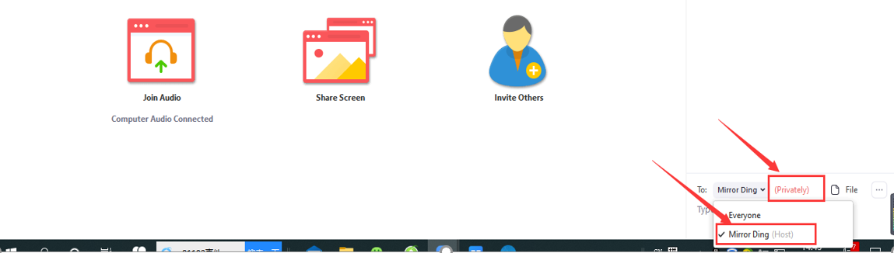

- If you have any question about the keynote speech or authors’ presentation, please input the question in the chat box. Or, you could also input “1” in the chat box in the Q&A. In the Q&A, the host will invite and unmute you.
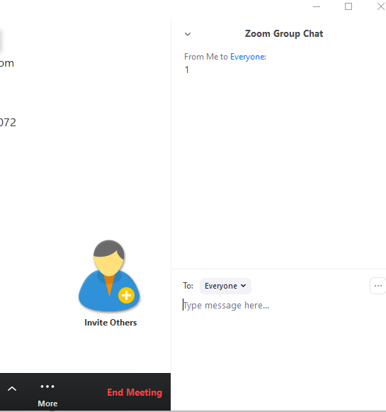

Step 5: Frequently Asked Questions
Question: When I sign in, ZOOM requests me to fill in China’s mobile phone number? But I’m not in China.
Answer: Sometimes, there may be a bug. So you could try to input the phone number with country code, such as, “001 9872367800”.

Question: If the Video inverted, what can I do?
Answer: Please click the button as followschoose the option “video” click the option “Rotate 90°”
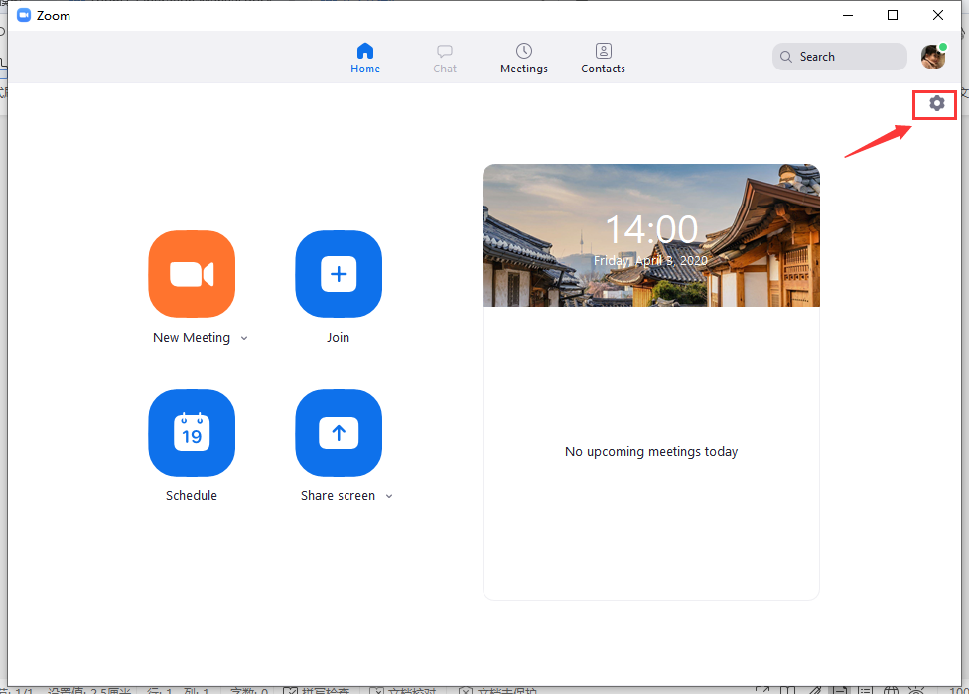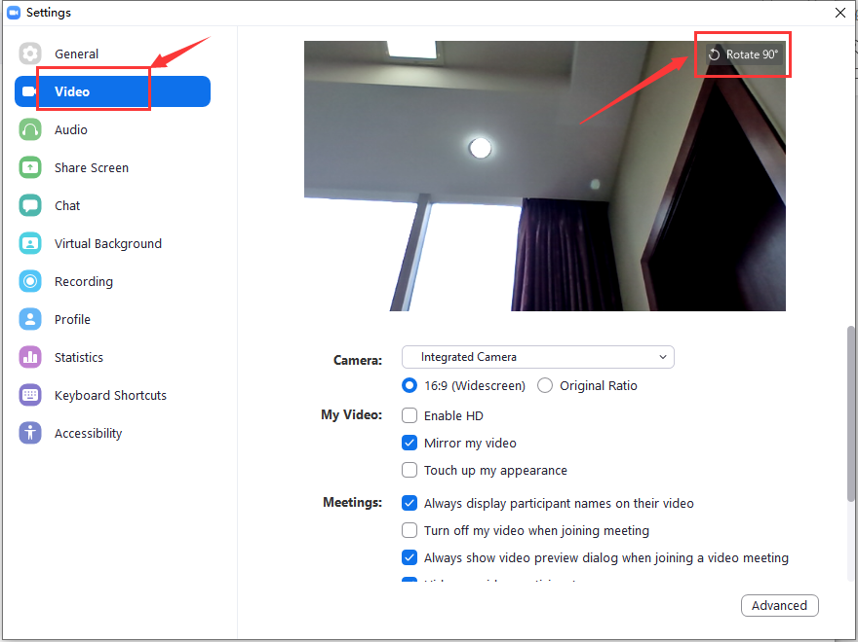

If there are other problems, welcome you to contact with our conference secretary by email with problem screenshot.

